
Dr. APJ ABDUL KALAM SCHOOL OF ENGINEERING
DEPARTMENT OF ENGINEERING

NAME OF THE STUDENT :UJALA YADAV
ROLL NO.:24BTCE147
BRANCH: BTech in Computer Science
COURSE : ADVANCE JAVA
ASSIGNMENT NO: 02
DATE OF ISSUED:21/08/2026
DATE OF SUBMISSION: 21/08/2026

Signature Of The Faculty

Develop a Student Registration and Validation System using Java Servlets, JSP, and JSTL. The application should provide a registration form through which students can enter their name, email ID, and course details.
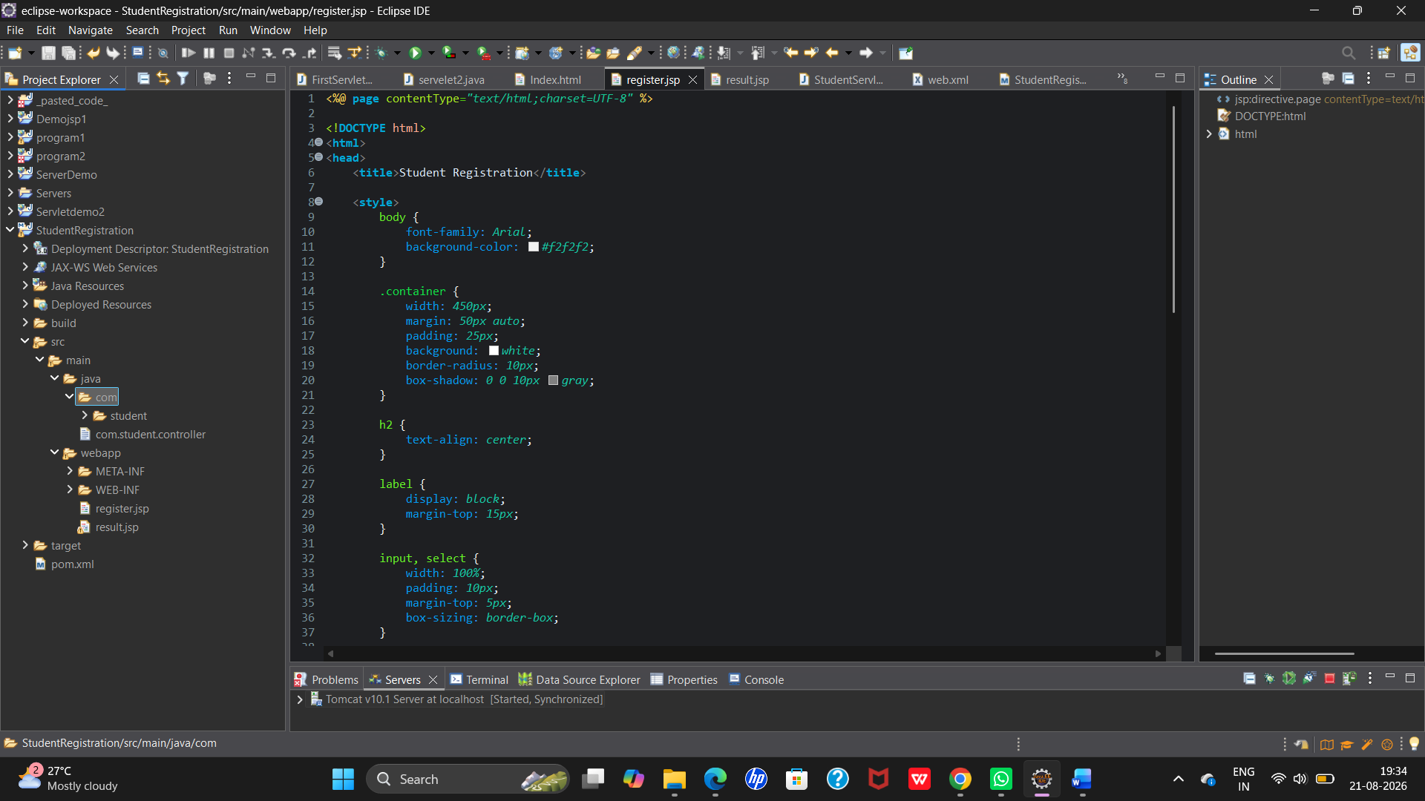

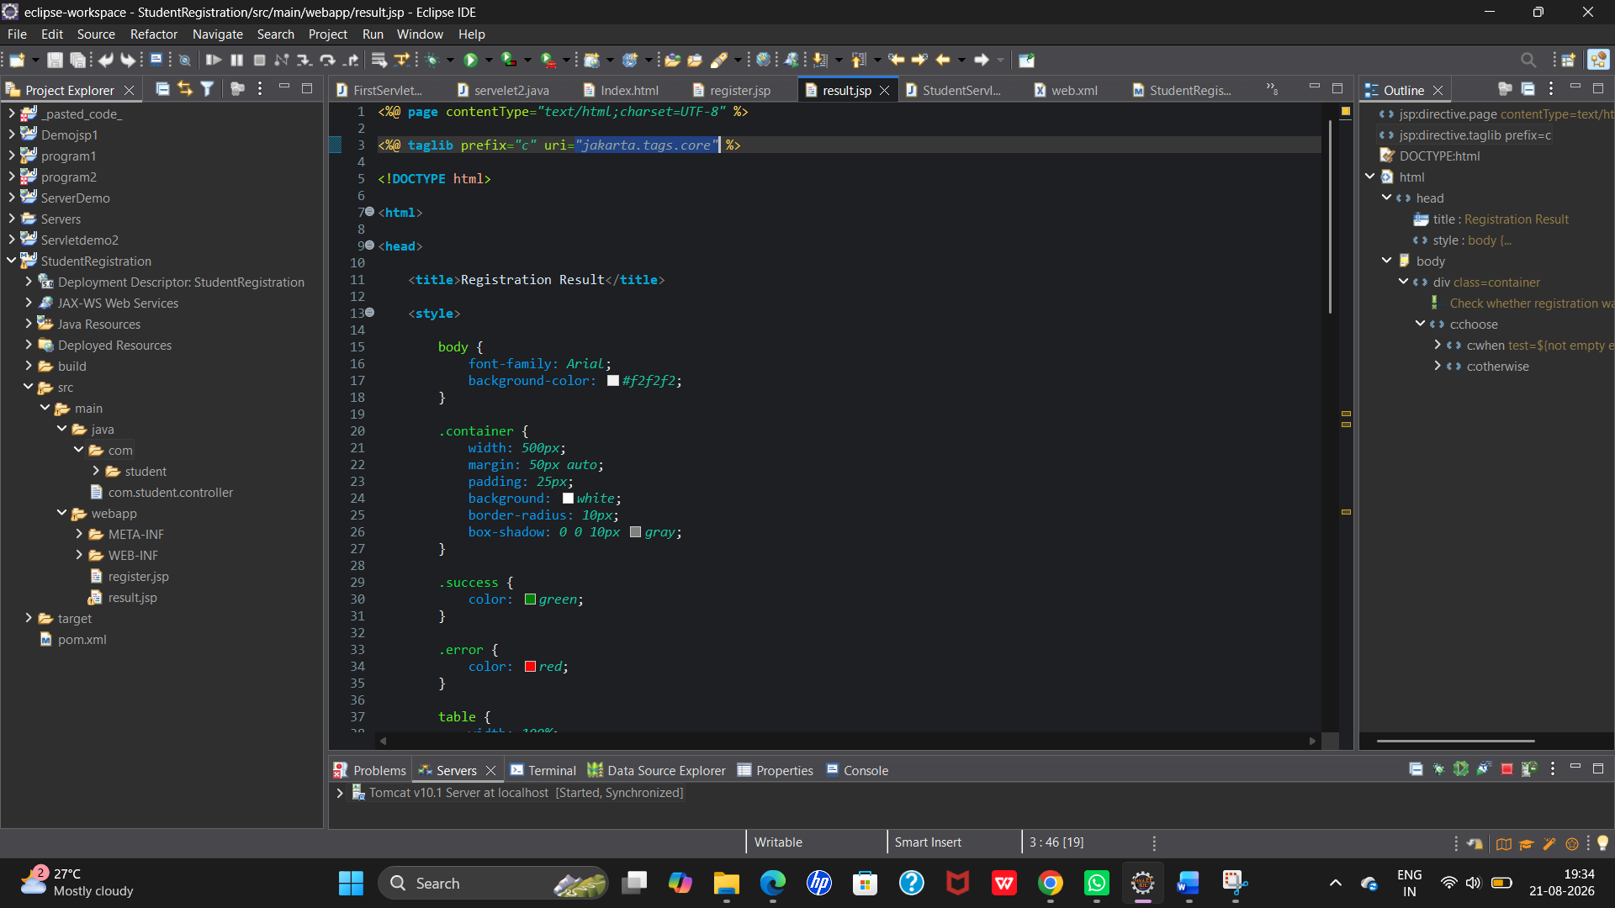

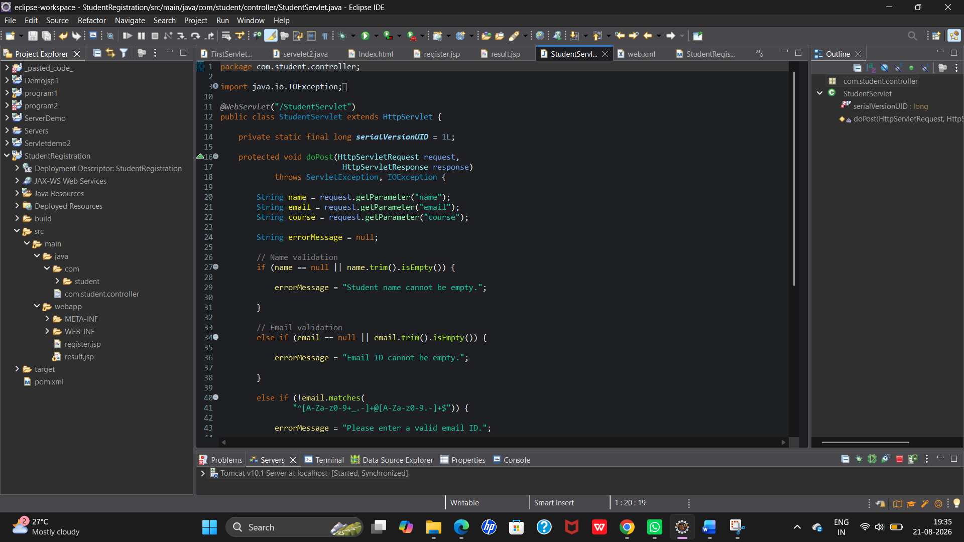

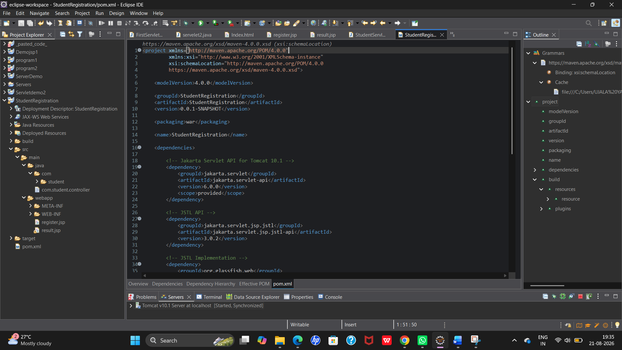

OUTPUT:
